Assessment

This outcome assessment will adhere to normal SQA submission regulations and be marked as a pass or fail with remediation given if a second attempt is required. It will also be taken into consideration along with other assessments to determine a holistic overall grade in place of your Graded unit exam.

Scotia Airlines
Scotia Airlines is a new budget airline operating between Glasgow Airport and the Western Isles.
It operates two 16-seater light passenger aircraft and requires a flight booking system.

Because Scotia offers low cost air travel, there is a need to treat each flight as single cost centre and to be able to ascertain, at any moment, the amount of the cash taken for that flight.

Reservations and bookings cannot be made until the flight details have been finalised (flight number, departure and arrival airports). A seat on a flight is considered booked when payment as been received for it. When a reservation is confirmed (changed to booked), the passenger name is checked against the original reservation.

A flight can be in any of the following states:
- Available for bookings
- Checking in
- Boarding
- Closed

When a flight is checking in, cancellations and bookings can be made but reservations cannot. No further reservations or bookings can be made if a flight is boarding or closed. A flight can be closed automatically by the system if it is full or by a user on receiving a telephone call from the duty manager (e.g. when it is ready for take off). Users of the system, therefore, have to be able to view a seating plan of the aircraft detailing free, reserved and booked seats. There is also a requirement to view information on a particular seat (e.g. status, passenger name, type of passenger, amount paid for the seat).

There is a no refund policy on booked seats. This means that a seat can be re-sold and a new ticket issued, making extra revenue in the process.

The company currently operates a discount scheme. Western Isles residents get a 10% discount.
Scotia also records the island of residence of these passengers for marketing purposes. Business travellers get a 25% discount and must supply their company name. Ordinary passengers do not normally receive a discount unless it is part of a current promotion, in which case they receive a 5% discount.
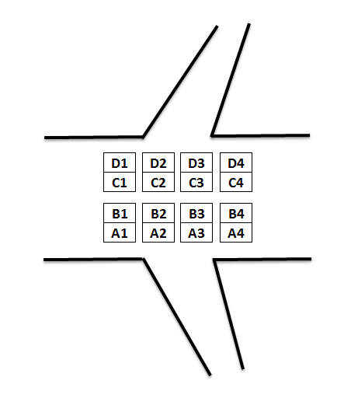

Within the OOPs environment, you will investigate evidence of
- Object oriented concepts and terms
- Object oriented programming techniques
- Objects and classes
- Attributes and methods
- Parameter passing
- Abstraction and encapsulation
- Inheritance
- Polymorphism
- Association
- Aggregation and collection
- Coupling and cohesion

Within the programming implementation, you will show evidence of
- Declaring and initialising variables
- Using operators
- Implementing control structures
- Defining data structures
- Accessing and manipulating data structures
- Using parameter passing
- Creating Classes
- Creating instances of classes
- Creating relationships between classes
- Creating Constructor methods
- Overloading methods
- Use of exceptions
- Use of standard object libraries including linking to SQL
- Documenting code

Additional Information

Flight Number Departure Arrival
SA123 GLA (Glasgow) LON (London)
SA124 LON GLA
SA234 GLA ABR (Aberdeen)
SA235 ABR GLA
SA345 GLA SYY (Stornoway)
SA346 SYY GLA

- Assume each seat costs £100.00
- Assume each plan has the 16 seats (A1 to 4D).
- All data must be stored and retrieved from an external database (MySQL)

Task 1

Implement a solution to this problem using the appropriate OO environment (see appendix 1)

Specifically, the following features must be demonstrated in the candidate’s program listing:
- Class and instance variables are appropriately defined, declared and initialised. At least one class must be abstract.
- Arithmetic or logical operators are correctly used
- Appropriate mathematical, character, or date (or time) functions are correctly used
- Control structures, sequence, selection and iteration are correctly used

Use of object-oriented programming concepts

- Constructors are correctly used
- Encapsulation is correctly used
- Inheritance and polymorphism are correctly used
- Correct use of visibility – public, private and protected variables and methods
- Message passing is correctly used

Appropriate parameter passing is correctly used
Modules are internally documented to organisational standards
Appropriate error and contingency handling requirements are correctly used.

Task 2

Test the completed product

- Implementing a test plan using a defined strategy (appendix 2)
- Maintaining a test documentation (appendix 3)
- Evaluating results of test runs (comments)
- Amending coding as necessary

The following is an example of the detailed test log which required for each module/class.

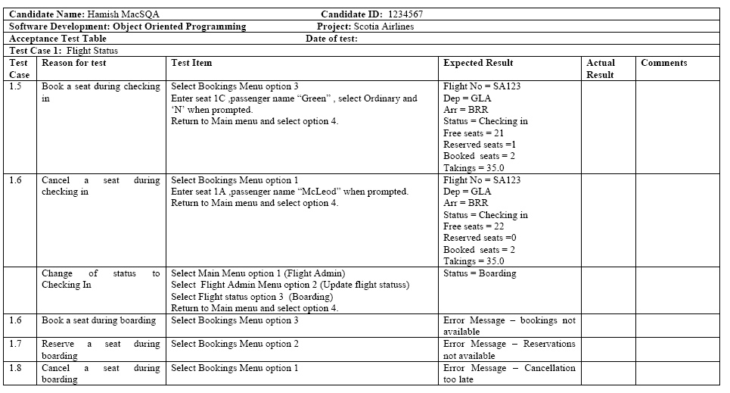

Appendix 1

Class Diagram

This diagram is indicative of the possible content of your classes and can be modified if justification is given.

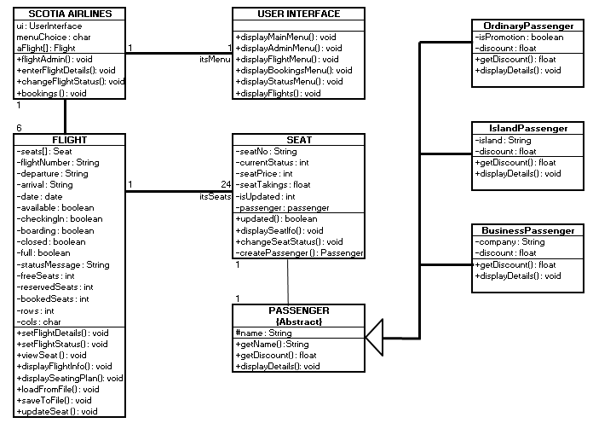

Possible menu hierarchy

This diagram is indicative of the possible content of your menus and can be modified if justification is given.

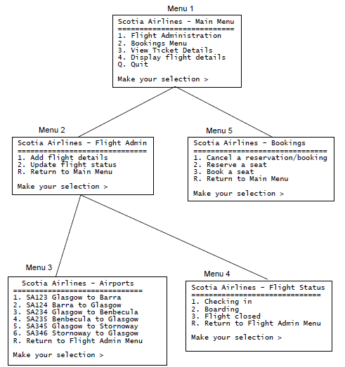

You will not be required to produce code which will fully comply with the menus above if there is sufficient evidence within the code the cover all of the required knowledge and understanding described in the descriptor.
Use Case Diagram

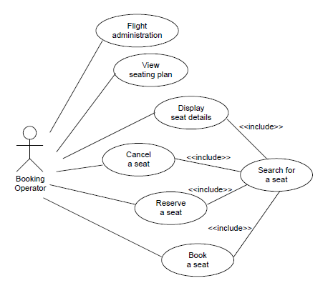
USE CASE DESCRIPTIONS
Name: Cancel a seat
Pre-condition: Seat is reserved or booked
Post-condition: Current seat status is changed to free, Passenger .

Trigger: changeSeatStatus (newStatus, newPassengerName) associated with Seat

Main flow of events:
1. Booking operator enters seat number
2. System searches for seat
3. Current status is reserved [A1] [E1]
4. Current status is set to new status
5. Passenger details are initialised and use case terminates

Alternative flow of events:
A1 Current status is booked
Exceptional flow of events:
E1 Current status is already free. An error message is displayed and use case terminates

Name: Reserve a seat
Pre-condition: Current seat status is free
Post-condition: Current seat status is changed to reserved.

Trigger: changeSeatStatus (newStatus, newPassengerName) associated with Seat

Main flow of events:
1. Current status is free [E1], [E2]
2. Set current status to new status
3. Set passenger name to new passenger name

Exceptional flow of events:
E.1 Current status is reserved and an error message is displayed
E.2 Current status is booked and an error message is displayed

Name: Book a seat
Pre-condition: Current seat status is free or reserved
Post-condition: Current seat status is changed to booked.

Trigger: changeSeatStatus (newStatus, newPassengerName) associated with Seat

Main flow of events:
1. Current status is free [A1] [E2]
2. Set current status to new status
3. Set passenger name to new passenger name

Alternative flow of events:
A.1 current status is reserved. The passenger name is checked to see if it matches the name under which the reservation was made [E1].

Exceptional flow of events:
E1 Current status is reserved and names do not match. An error message is displayed.
E2 Current status is booked and an error message is displayed.

Appendix 2 – Test Strategy

The test strategy should outline the incremental steps which you have taken to develop each class. For example, if you have designed and implemented the customer relationships first and tested these using a driver class then the entry would be test number 1, test description development of customer. If the next stage was the development of a single seat then the test number would be 2 etc.

Each entry in the test plan will have a corresponding test log which will detail each test carried out.

Test Plan (Strategy)
System: Scotia Airlines |  | Candidate number and name:
Test No: | Test Description
1 | Create, implement and full test the class structure to mirror the PASSENGER and all subclasses including Ordinary, Island and Business passengers identified in the UML class diagram.
2 | Create, implement and full test the class structure to mirror the SEAT class identified in the UML class diagram.
3 | Create, implement and full test the class structure to mirror the FLIGHT class identified in the UML class diagram
4 | Create, implement and full test the class structure to mirror the AIRLINE class identified in the UML class diagram
5

6

Appendix 3 – Test Log

Each item in the test strategy will have the corresponding tests carried out recorded in the test log. If the test number in the test strategy is 1 the corresponding test number in the log would be 1.1, 1.2, 1.3, 1.4 etc. You should complete a test log for each item in the test strategy.

Candidate Number and name
Software Development: Object Oriented Programming: Scotia Airlines
Acceptance Test Table |  | Class Name
Test Nos | Reason for test | Test Items |  | Expected results |  | Actual results | Comments and corrections

Assessment Deadlines

It is important that you full embrace the need to plan and develop your code in a methodical and logical manner. With this in mind intermediate deadlines have been set to ensure that you keep on track and complete the assessment within the allocated time.

Date | Friday 19th February (indicative)
Class completed | Passenger  Ordinary  Island  Business  Passenger Driver (containing main())  Completed Test Strategy  Completed Test Log (for above classes)
Date | Friday 5th March (indicative)
Class completed | Seat  Seat Driver (containing main())  Completed Test Log (for above classes)
Date | Friday 2nd April (indicative)
Class completed | Flight (excluding MySQL connections)  Flight Driver (containing main())  Completed Test Log (for above classes)
Date | Friday 30th April (indicative)
Class completed – will meet the needs of SQA unit | Flight (with MySQL connections)  Flight Driver (containing main())  Completed Test Log (for above classes)
Date | Friday 21st May (indicative)
Class completed | Aircraft  Aircraft Driver (containing main())  Completed Test Log (for above classes)

